Mini Yelp

This is a portable web that can let user to check, search and get recommendation of the restaurants nearby.

To run the server on local host needs lots of dependents and may be complicated to configure. So we allocated our server to cloud based network service. Just click the following link:

<http://54.187.102.57:8080/Dashi/>

and you will see the following page:

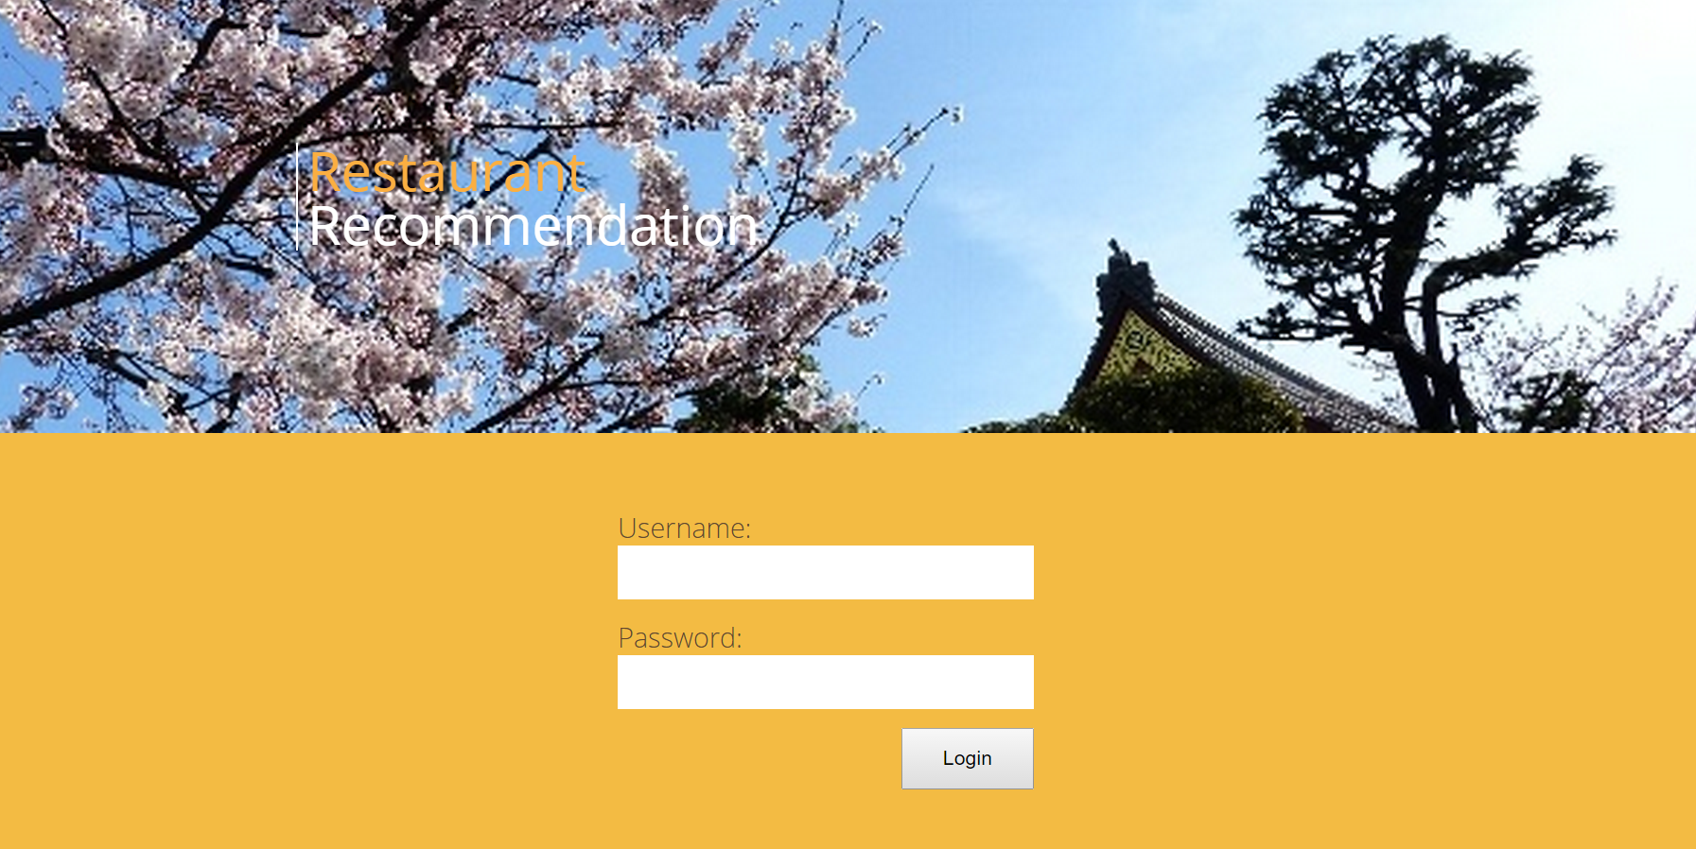

The web is user based and we need to login first. Input:

Username: 3333

Password: 3333

And click “Login”. If the following shows:

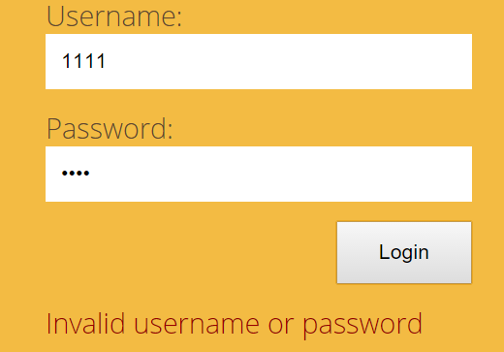

This is because the Tomcat server sometimes needs to be restarted. Please contact Yiwei Guo by [yiweiguo0301@gmail.com](mailto:yiweiguo0301@gmail.com) or 415-323-8417 or Gongyao Chen by [gongyaoc@seas.upenn.edu](mailto:gongyaoc@seas.upenn.edu) or 724-289-0902 for help.

If successfully logged in, then we will login to the main page that shows your nearby restaurants:

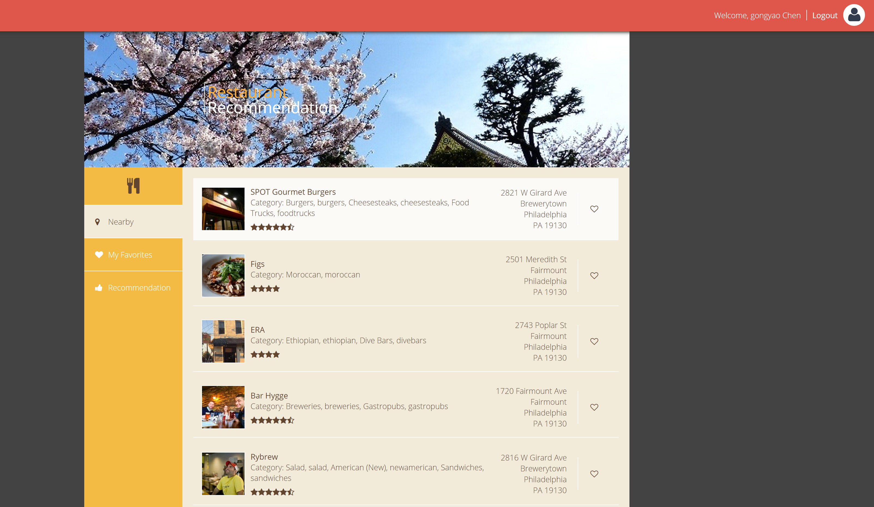

If we want to check a restaurant to be visited, then we can click the empty heart in red circle:

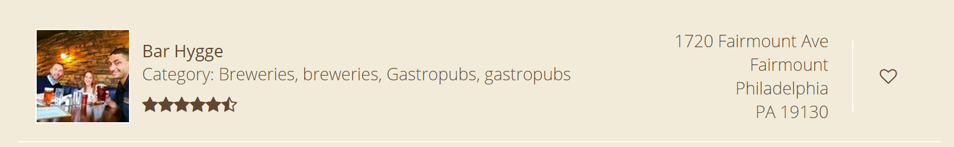

Then the heart will become solid and we can see these checked restaurants in “My Favorites”:

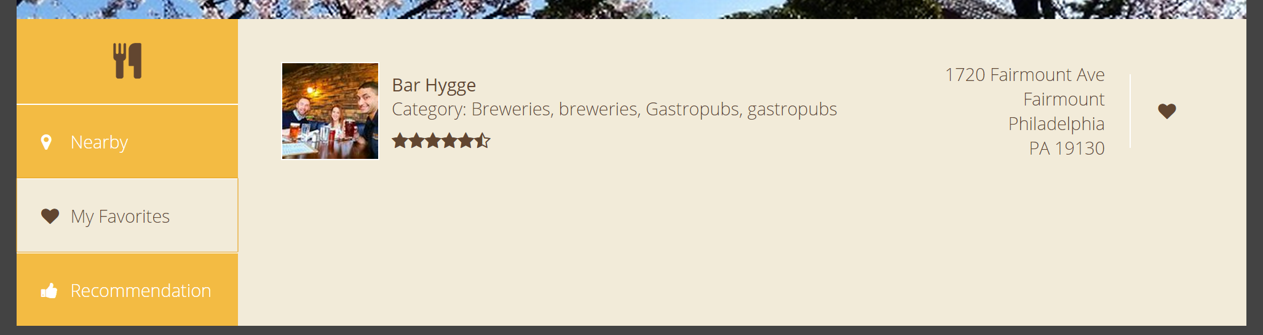

If we have favorite restaurants, we can get recommendation now. Click “Recommendation” and the recommendations will show:

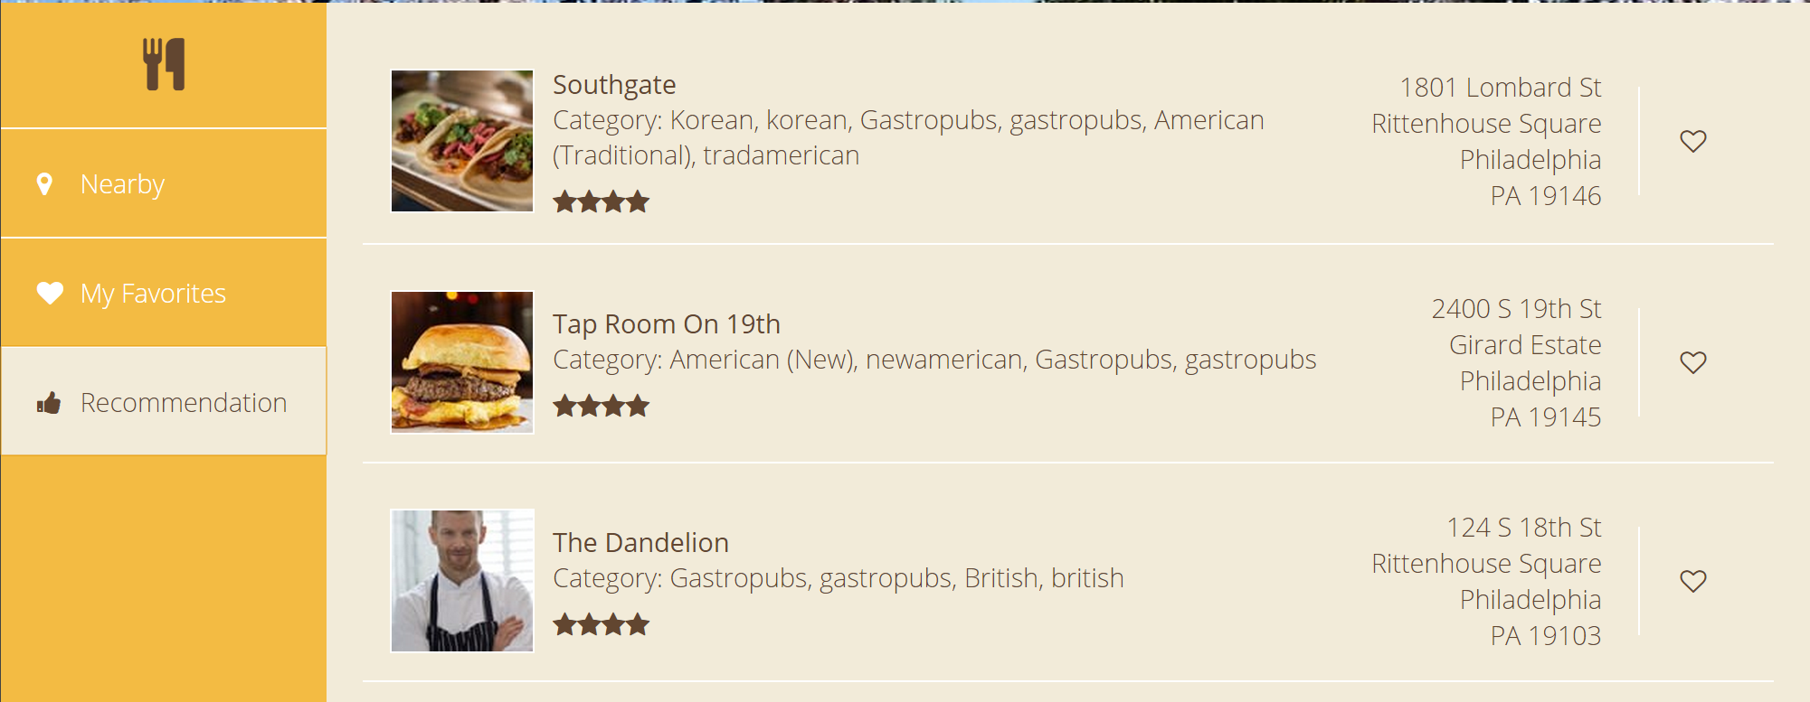

We can click on the name of the restaurant in red circle, and it will redirect us to its Yelp page:

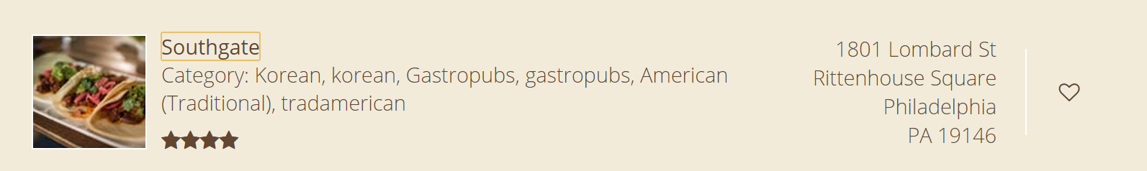

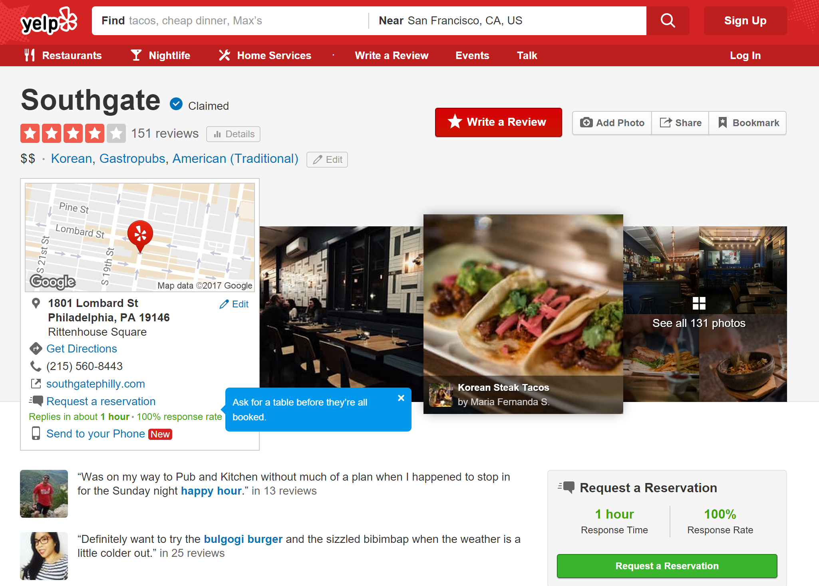

If we don’t want to favor a restaurant any more, click the solid heart and it will become empty again. Then this restaurant will disappear from “My Favorites”.

Click “Logout” on the upper right corner to log out.